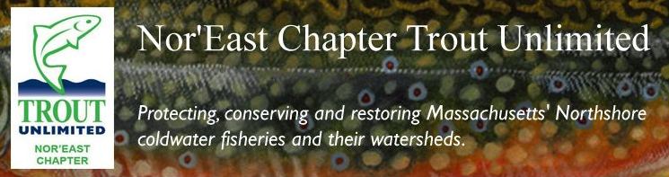

Dear Friend,

The Nor’East Chapter of Trout Unlimited is holding its fund raising banquet on **Saturday, March 18, 2017**. We hope that you will consider supporting our chapter by **making a donation** to be included in our auction and/or **purchasing an ad** for our Banquet Program Booklet (see back of this page for ***advertising rates*** and ***examples of past auction donations***). This annual banquet has proven to be our best fund raiser as individuals and businesses generously donate goods and services in the name of local environmental action.

Trout Unlimited is a national conservation organization of over 140,000 members dedicated to the conservation, protection and restoration of North America's coldwater fisheries and their watersheds. The Nor’East Chapter is TU’s presence on the north shore of Boston.

Locally, our projects are aimed at improving stream flows, restoring habitat, assuring fish passage and educating the public on the benefits of clean rivers.

The funds we raise at our banquet go directly toward our localconservation, education and outreach programs.

To date, funds we have raised have been used for programs and projects like:

* Purchasing equipment to allow students to raise trout in local school classrooms
* Paying for culvert replacements allowing for North Shore streams to flow freely
* Researching and implementing local dam removal and fishway projects where feasible
* Purchasing supplies necessary for stream cleanups and other river habitat improvements
* Paying speakers honoraria for educational presentations at public meetings

Please know that we greatly appreciate any support you can offer, and that your contribution will be listed in our banquet program.

Thank you for your time and generosity.

Sincerely,



Frederic B. Jennings Jr.

NETU President

Trout Unlimited is incorporated as a 501(c)(3) non-profit educational, charitable  
organization, and all monetary or property donations are tax deductible to the extent  
allowed by law.

Tax ID 510208529

**NOR’EAST CHAPTER TROUT UNLIMITED**

**ANNUAL FUNDRAISING BANQUET**

**Saturday, March 18, 2017**

**NETU AUCTION PROGRAM BOOK – AD OPPORTUNITIES RESPONSE FORM**

**Full Page Ad (5” x 8”) $100 ____ Quarter Page Ad (2½” x 4”) $40 ____**

**Half Page Ad (4” x 5”) $60 ____ Business Card Ad (2” x 3½”) $25 ____**

**Name:__________________________________________ Company:__________________________**

**Street Address: ______________________________________________________________________**

**City/Town _______________________________ State:______________ Zip Code________________**

**Telephone____________________________ E-Mail_________________________________________**

**TU CONTACT PERSON:_______________________ Telephone:________________**

**Checks payable to: Nor’East Chapter Trout Unlimited Amount Enclosed: ____________**

***Please return this form with a business card or camera ready art work no later than Friday, March 3rd, 2017 in order to ensure acknowledgement in the program book. Send payment and art work to:***

***Michael G. O’Neill, 104 Lowell Road, Apt 103, North Reading, MA 01864***

**SOME EXAMPLES OF NETU AUCTION ITEMS DONATED IN 2016**

**GIFT CERTIFICATES (for restaurants, classes, personal training, cleaning services, supermarkets, etc.)**

**FISHING FLIES AND EQUIPMENT (fly boxes, fly rods, reels, nets, chest/fanny packs, tools, totes, etc.)**

**FLY TYING MATERIALS AND TOOLS (vises, hooks, feathers, thread, pliers, glue, bucktails, necks, etc.)**

**BOOKS AND ART WORK (fishing books, fishing prints, framed photos/flies, hand-made jewelry, etc.)**

**MISCELLANEOUS GIFTS (wine/beer, coasters, vases, briefcase, travel bags, tools, grill sets, clothing, coolers, hand-made boxes, tools, knives, greeting cards, gas grille, chairs, binoculars, cameras, etc.)**

**GUIDED FISHING TRIPS (Ipswich, Cape Cod, Red Brook, Deerfield, Swift, Dennys, Kennebec Rivers…)**

**\* * * * \***

**Trout Unlimited is incorporated as a 501(c)3 non-profit educational organization, and all monetary or property donations are tax deductible to the extent allowed by law. Tax ID # 51-0208529**